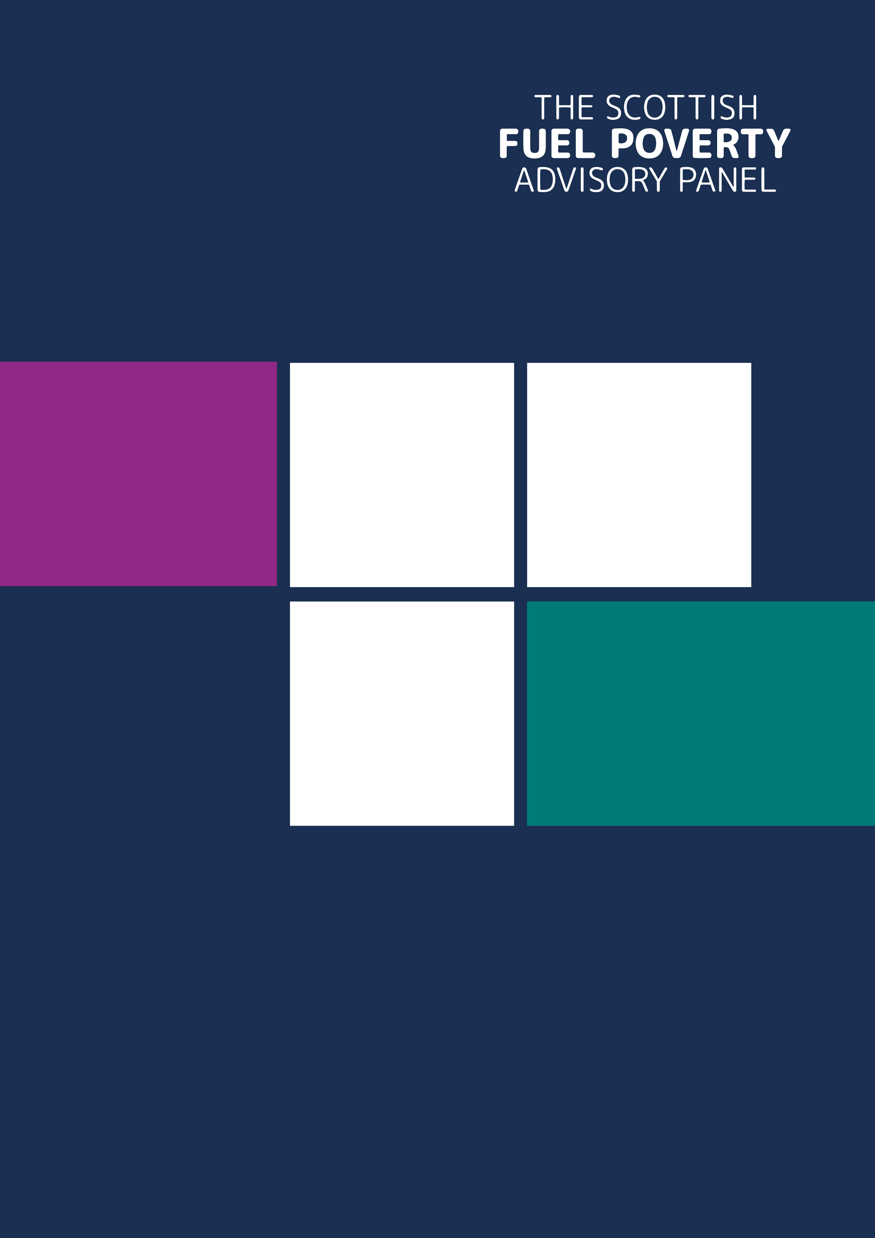
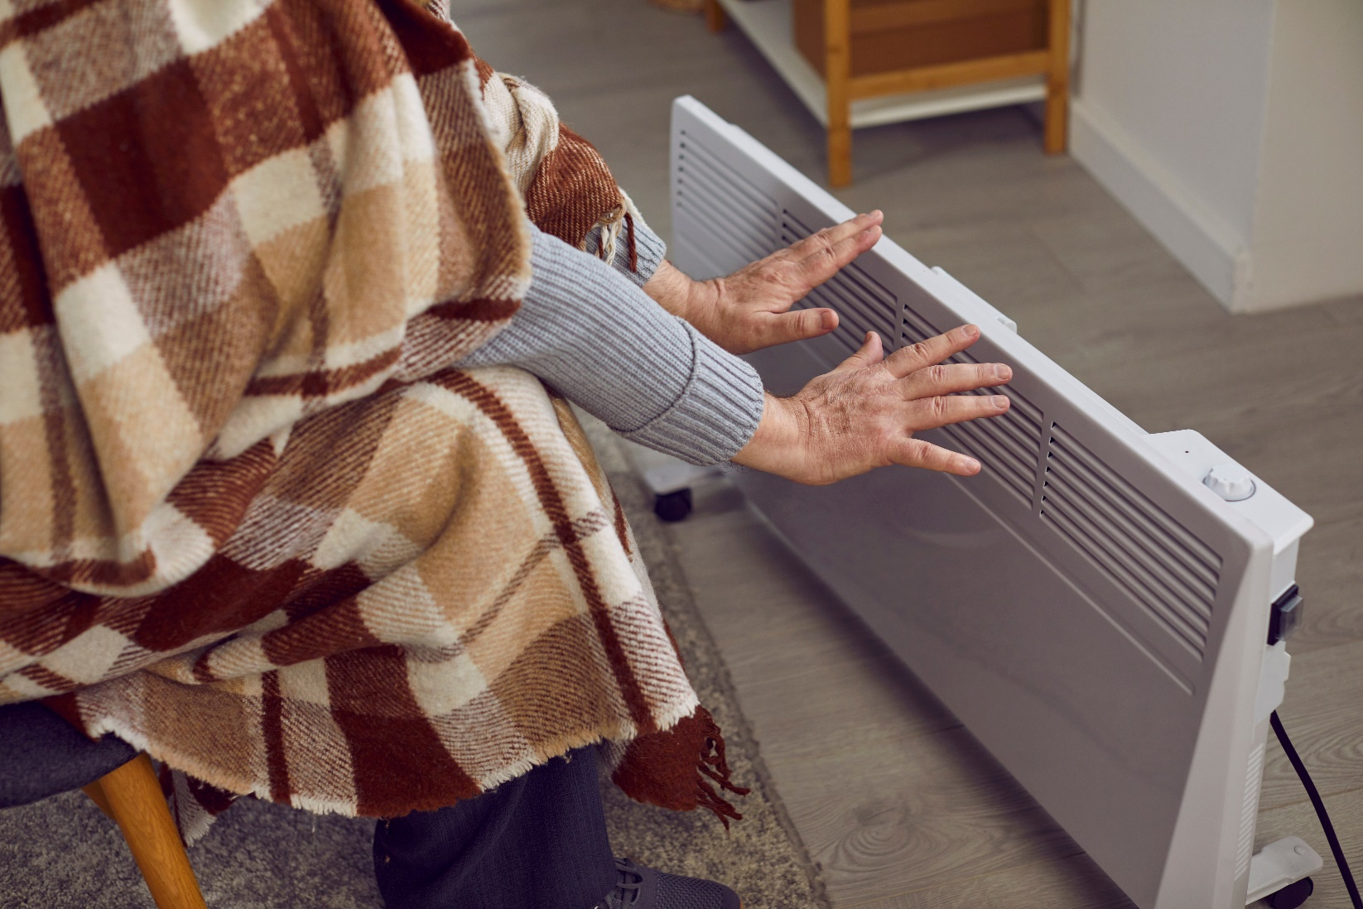
Annual Report
2025 – 2026

August 2026

The Scottish Fuel Poverty Advisory Panel

Contents
Foreword from the Chair 3
About us 5
Our Approach 6
Our Work since April 2025 8
Priorities 8
1. Respond to the Scottish Ministers’ Periodic Report 8
2. Explore solutions to rural and remote fuel poverty – building on last year’s work 11
3. Look forward to exploring the benefits of a public health approach to fuel poverty in 2026-2027 by setting the groundwork for this in the final quarter (January - March 2026) 12
Our plan 12
Scrutiny 14
Advocacy and Influence 14
Advice 15
Governance 17
Monitoring the Success of our Strategic Plan 18
Members of the Panel 19
Financial Summary 21

Foreword from the Chair
As we look back on the last year, it is clear that the challenges facing households across Scotland remain significant. Recent months have demonstrated just how vulnerable our energy system remains to events beyond our borders. While there were encouraging signs earlier this year, with falling energy prices and a welcome reduction in fuel poverty levels, albeit based on 2024 data, the renewed conflict and instability in the Middle East have once again highlighted the fragility of global energy markets and the direct impact this can have on households struggling to afford essential heating and power. These developments serve as a stark reminder that fuel poverty is not simply a consequence of individual circumstances. It is shaped by international events, volatile energy markets, the energy efficiency of our homes, and the effectiveness of public policy. Too many households remain exposed to price shocks they cannot control and cannot absorb.
Against this backdrop, the need for long-term, sustainable solutions has never been greater. Scotland's ambition to reduce fuel poverty to 15% by 2030 remains an important and necessary goal, but as we reflected in our statutory response to Scottish Ministers’ triennial fuel poverty report, achieving it will require renewed urgency, decisive action and sustained investment. Support must continue to reach those in immediate crisis, while progress on improving the energy efficiency of homes and reducing dependence on volatile fossil fuel markets must accelerate. This support can be driven by both the Scottish or UK Governments. As we have seen through the proposed reduction in VAT on household electricity bills, change can be made quickly to provide some in year benefits.
It is in this context of uncertainty and rising concern over energy affordability that we delivered our priority work programme for the year. During 2025-26, we continued to fulfil our statutory role of advising Scottish Ministers and scrutinising progress towards Scotland’s fuel poverty targets. With a membership that expanded to six members towards the end of the year, supported by a small Secretariat, we met regularly in person and online to deliver our workplan priorities, engage with stakeholders and provide independent advice across the fuel poverty landscape.
- A major focus of the year was our statutory response to the Scottish Government’s first triennial Periodic Report on fuel poverty (2021-2024) - completed before our new members joined us. We examined progress towards the statutory fuel poverty targets, assessed the likelihood of achieving future targets, reviewed how the four drivers of fuel poverty are being addressed, and looked forward to how a revised Fuel Poverty Strategy could better support the mitigation of fuel poverty and meeting the fuel poverty targets. Our view is that greater strategic priority must be given to fuel poverty policy, accelerating the rate of improvements to the energy efficiency of the housing stock is a prerequisite for meeting the statutory targets, alongside greater focus on affordability and more effective consideration of how energy is used in the home.
- We also built on our previous work on rural and remote fuel poverty, publishing the findings of the work we commissioned on the lived experience of rural and remote fuel poverty. We also engaged with island local authorities and stakeholders. We examined the structural drivers that cause our island communities in Scotland to suffer the worst fuel poverty in Scotland and beyond. This work highlighted the need for more coordinated action, targeted investment, improved local delivery capacity and energy market reforms that better reflect the circumstances of remote and island communities.
- A further priority was exploring the links between fuel poverty and health. We have undertaken research to examine how a public health approach could strengthen fuel poverty interventions. This work has identified opportunities to improve health outcomes through warmer homes, better use of data, stronger partnerships and embedding fuel poverty support within existing health services.
- Alongside our core priorities, we have continued to advocate for a flexible energy discount mechanism, contributed to consultations and working groups, provided advice on major policy developments, supported research, and collaborated with a wide range of stakeholders. Through these activities, the Panel sought to influence policy, strengthen evidence and support progress towards the long-term goal of eradicating fuel poverty in Scotland
I would like to take this opportunity to thank our longstanding Panel members, Kirsten Jenkins, Alister Steele and Fraser Stewart – as well as new members Bryan Leask and Olivia Swann, who joined us this year, for their support, passion, and unwavering challenge. I would also like to recognise the work of the Secretariat – Roanna Sefton and Trisha Melvin and headed up by Philippa Brosnan – for their continued drive and determination to ensure that the SFPAP has a material impact. As ever, I welcome any feedback or perspectives that you might want to share. Please do get in touch with me at enquiries@fuelpovertypanel.scot.

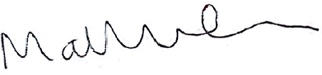

Matthew Cole
Scottish Fuel Poverty Advisory Panel – Chair

About us

The Scottish Fuel Poverty Advisory Panel was first appointed on 1st January 2022. We are an advisory non-departmental public body which provides independent advice to Scottish Ministers on fuel poverty and scrutiny of their progress towards delivering Scotland’s 2040 fuel poverty targets. As well as the 2040 target to, effectively, eradicate fuel poverty, there are two interim targets: the 2035 target that no more than 10% of households are in fuel poverty, no more than 3% are in extreme fuel poverty and the median fuel poverty gap is no more than £300, and the 2030 target – just four years away – that no more than 15% of households in Scotland are in fuel poverty, no more than 5% are in extreme fuel poverty and the median fuel poverty gap is no more than £350.
We are here to help the Scottish Government work on short, medium and long-term fuel poverty issues and potential solutions, including how support can best be provided to those in, or entering, fuel poverty.
The Fuel Poverty (Targets, Definition and Strategy) (Scotland) Act 2019 sets out specific requirements for the Panel in relation to fuel poverty. These include:
- commenting on Scottish Ministers progress on fuel poverty targets.
- advising Scottish Ministers on how policies and programmes are addressing the four drivers of fuel poverty:
- High energy prices.
- Poor energy efficiency of the home.
- Low household income.
- Energy consumption.

The Tackling Fuel Poverty Strategy 2021 extends the Panel’s role to include:
- Supporting an evidence-based approach to fuel poverty which puts those with lived experience at its centre.
- Advising on the delivery of the Fuel Poverty Strategy, including on the mechanism for how the strategy-delivery is monitored and evaluated.
- Championing and fostering a collaborative approach to addressing fuel poverty across Scotland.
- Advising Scottish Ministers on the impact of new evidence, technologies, and opportunities to tackle fuel poverty.

We are a small Panel of six members and worked 81 days this year. We operated as a Panel of four until the appointment of our two new members in January 2026 and were supported by a Secretariat of 2.5.
We collectively have experience of working to support – either directly or indirectly – those struggling to manage their energy bills. We bring knowledge of the strategies and policies across the fuel poverty landscape and the wider energy system, fuel poverty research, the health impacts of fuel poverty, how housing condition can mitigate or exacerbate fuel poverty, as well as first-hand and real-life experience of how difficult life can be when fuel bills become unaffordable.

Our Approach

Since the Panel was first appointed, we have been working to:

- Engage widely with stakeholders across the fuel poverty landscape – in Scotland and beyond – including those with lived experience of fuel poverty, third sector organisations, national and local governments, and Ofgem.

- Reflect on the Scottish Government’s Tackling Fuel Poverty Strategy which shapes and sets the direction for fuel poverty policy in Scotland, offering advice and recommendations to the Scottish Government on the strategy and progress towards its outcomes. Specifically, offering advice on the shape of the revised Fuel Poverty Strategy in our response to the Scottish Government’s Tackling Fuel Poverty in Scotland: periodic report 2021-2024.

- Contribute to the work to mitigate fuel poverty through participating in cross-sector groups, key consultations, offering Ministers advice and exploring the possibilities for both short and longer-term measures to alleviate, and ultimately eradicate, fuel poverty.

- Achieve our vision, mission and principles (which follow below) and objectives. Our objectives are reflected in our Strategic Plan for April 2024 to March 2027 and our workplan for this year April 2026 to March 2027, and our previous two workplans.

- Sustain high standards of governance across the Panel's work.

Our Vision, Mission, and Principles


The Panel’s vision is for:
A Scotland where everyone lives in an energy efficient home and has access to affordable clean energy – a Scotland where no one lives in fuel poverty.




The Panel’s work is driven by its mission to:
Strengthen fuel poverty policy, legislation and practice
in Scotland and the UK.
Eradicate fuel poverty and increase resilience by engaging
with people with lived experience and those who support them.
By advising Scottish Ministers, scrutinising progress,
and advocating for action.

In working to realise our vision and achieve our mission, the Panel aims to foster
an ethos supported by these principles:

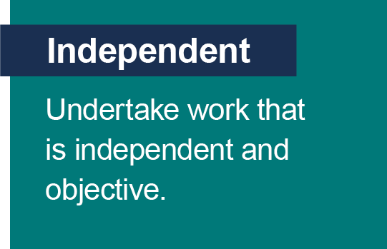
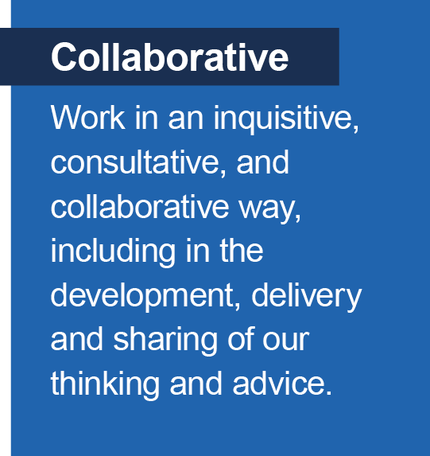
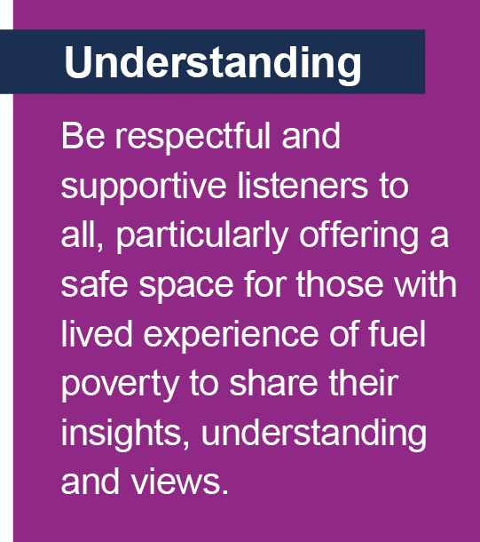
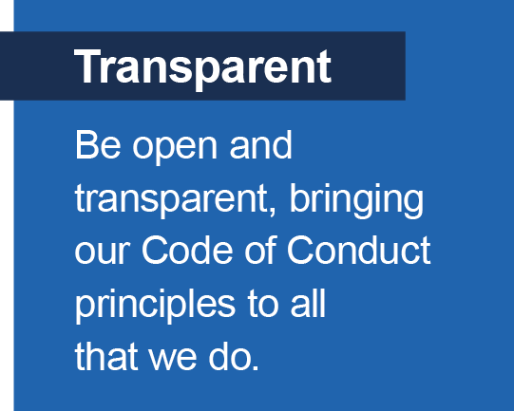
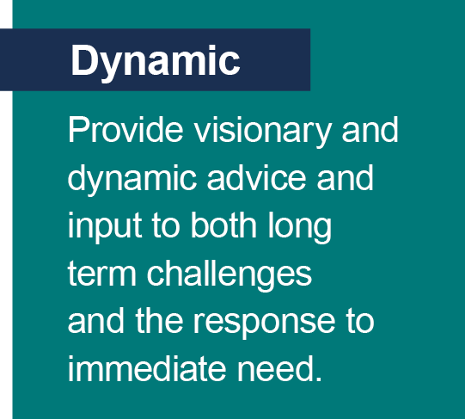
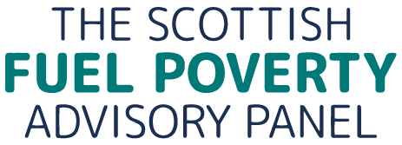

Our Work since April 2025
In delivery of our April 2025 to March 2026 workplan, we have met four times in person and twelve times online to deliver on our workplan priorities. We have also worked to advise and influence the Scottish and UK Governments, and Ofgem through direct advice to policy officials, responding to consultations and participating in the Scottish Government’s Social Tariff Working Group and sector conferences.

Priorities
In our April 2025 to March 2026 workplan we set out three core priorities for the year. These were to:
1. Respond to the Scottish Ministers’ Periodic Report – as required by provision 14 of the Fuel Poverty (Targets, Definition and Strategy) (Scotland) Act 2019 by the end of the second quarter (September 2025).
2. Build on last year’s work on the systemic impact of rural and remote fuel poverty in order to explore solutions to rural and remote fuel poverty.
3. Look forward to exploring the benefits of a public health approach to fuel poverty in 2026-2027 by setting the groundwork for this in the final quarter (January - March 2026).
This year we have also continued to work flexibly to respond to consultations on key issues for those in fuel poverty. In addition, we carried out an exploration of the evidence on income-based support versus money off energy bills for fuel poverty support, a topic often raised by stakeholders and which is important in effective policy responses and progressing Scotland’s fuel poverty targets.

1. Respond to the Scottish Ministers’ Periodic Report

Our response to the periodic report was a significant piece of work, drawing together the evidence, analysis and advice developed over our first four years. It not only includes many of our previous recommendations to Ministers but also sets out a potential framework for revising the Fuel Poverty Strategy.
Our approach
On the 1 April 2025, Scottish Ministers published the first of their triennial periodic reports –Tackling fuel poverty in Scotland: periodic report 2021-2024, as stipulated by the Fuel Poverty (Targets, Definition and Strategy) (Scotland) Act 2019. The Act requires the Panel to respond to this periodic report within 6 months. In making our response, we explored the following questions mandated in provision 14 of the Fuel Poverty (Targets, Definition and Strategy) (Scotland) Act:
- What progress has been made towards meeting the fuel poverty targets?
- What is the likelihood of meeting the fuel poverty targets?
- To what extent are the four drivers of fuel poverty are being addressed?
- Are there changes which should be made to the fuel poverty strategy?

We also engaged with a small number of third sector organisations and Scottish Government policy leads to complement our reflections on our collective stakeholder engagement since appointment. The findings from the third sector engagement, the questions we posed to Scottish Government, and our feedback to their periodic report consultation, informed our response to the Scottish Government’s Tackling fuel poverty in Scotland: periodic report 2021-2024. Our work on the periodic report influenced our other two work priorities last year – rural and remote fuel poverty, and the impact of fuel poverty on health.
What we did
We used the majority of our Panel meetings, two thirds, to reflect on our advice to Scottish Ministers since our appointment, especially our feedback on the periodic report consultation, alongside the views of others and the status updates provided by Scottish Government, to discuss and formulate our response to the periodic report. In answer to the four questions posed by the Act.
What we concluded
Our headline conclusion is that Scottish Government needs to give greater strategic prioritisation to fuel poverty policy and programmes than has been the case since the Fuel Poverty (Targets, Definition and Strategy) (Scotland) Act 2019 came into force. We considered and offered our opinion, as directed by the Act and also presented recommendations for an improved approach to form a potential framework for revising the Fuel Poverty Strategy.
I. Progress towards meeting Scotland’s statutory fuel poverty targets.
There is little evidence that current policies and programmes are delivering progress towards the targets, and the Scottish Government's periodic report does not assess how far actions taken between 2021 and 2024 have contributed to meeting them. There is no monitoring and evaluation framework to enable assessment of whether actions are reducing fuel poverty and no evidence showing the impact of spending and programmes on fuel poverty rates. Reporting does not clearly link actions, outcomes, and progress towards statutory targets and there is limited data on who has benefited from interventions and whether measures have improved people's lived experience of fuel poverty.
- What is the likelihood of meeting the fuel poverty targets?

We recognise the important investment and policy activity, particularly in energy efficiency programmes. However, we concluded that rising fuel poverty levels, weak monitoring, lack of outcome measurement, and insufficient assessment of policy impacts mean there is little evidence that Scotland is currently on track to achieve its 2030, 2035 or 2040 fuel poverty targets. We believe progress needs to accelerate significantly, especially in improving home energy efficiency and addressing the impact of persistently high energy prices
- To what extent are the four drivers of fuel poverty are being addressed?

Some progress has been made in addressing fuel poverty drivers, particularly through energy efficiency programmes, with a 3% improvement in homes rated Band C or above in 2023, up around 3 percentage points from 2022. However, we believe this rate of improvement is not fast enough to meet statutory fuel poverty targets and there is insufficient evidence showing how energy efficiency programmes have reduced fuel poverty. Considerable financial support has been provided through winter heating payments, crisis funds and other support schemes to mitigate low incomes. However, we found little evidence demonstrating how these measures have reduced fuel poverty in the long term or contributed to achieving the fuel poverty targets. High energy prices are the primary cause for the increase in fuel poverty since the Strategy was published and the Scottish Government has worked to set out principles for a social tariff. How Energy Is Used in the Home is the least developed and least understood of the fuel poverty drivers.
IV. Are there changes which should be made to the fuel poverty strategy?

Looking forward to the revised Fuel Poverty Strategy due to be published in December, we made recommendations for delivering the following priorities:
- Accelerating the rate of improvements to the energy efficiency of the housing stock is a prerequisite for meeting the statutory targets. It will require increased investment, strong leadership and taking stock of current delivery frameworks.
- An increased awareness of challenges around how energy is used in the home and review advice models, their funding arrangements, and what works best.
- A fuel poverty delivery plan should include how to increase low household net income as related to the attainment of the fuel poverty targets, should cover a consideration of taxation levers, a cash first versus fuel bills first approach, and the balance of support for major policy actions, including the flexible energy discount mechanism and development of minimum income guarantee.
- With the transition to decarbonised domestic heating, affordable and stable long-term electricity pricing is essential. A clear vision is needed for how the GB energy market could operate and the Scottish Government should advocate for the reforms which are not only in the best interests of consumers in Scotland but will also benefit those in, and at risk of, fuel poverty.
- Island and remote rural communities should have a specific, more focused and co-ordinated, approach for tackling fuel poverty with clear leadership and enhanced resources.

2. Explore solutions to rural and remote fuel poverty – building on last year’s work

Our plan
Insights from our scrutiny of the Scottish Government’s periodic report, and our previous work on rural and remote fuel poverty, shaped our work to identify and explore solutions to fuel poverty in rural and remote communities. We planned to:

❖ Build on our previous work, exploring what different solutions are being deployed across rural and remote Scotland to mitigate fuel poverty, what issues these unearth and how effectively they are addressing fuel poverty in their local communities.
❖ We will, explore with a range of rural and remote stakeholders, solutions to rural and remote fuel poverty. Following our postponed visit to na h-Eileanan Siar (the Western Isles) last year, we will consider how and where a rural visit could best support this stakeholder engagement.
What we did
We held 6 meetings with the 3 island local authorities and the 3 local authorities with islands in their jurisdiction, in the final quarter of this year’s workplan – January–March 2026. In these individual meetings we explored the drivers of fuel poverty in island communities and how they can be mitigated ensuring that any local drivers were understood. We produced a findings’ report mapping drivers and mitigations to the 4 drivers of fuel poverty, plus an additional driver – the remote and rural factors which exacerbate fuel poverty in island communities. We brought all these local authorities together in an island fuel poverty roundtable on the 17th of March to explore further the priorities for tackling island fuel poverty which emerged from our individual discussions. Our reflections on what we heard at the roundtable form the basis for advice which we will be giving over the summer to Scottish Ministers as they work to revise the Fuel Poverty Strategy.

What we concluded
Island communities in Scotland suffer the worst fuel poverty in Scotland and beyond. Fuel poverty in island communities is systemic and linked to the wider energy system. Fuel poverty in these areas is not incidental but structural. Our findings and recommendations have yet to be published but our recommendations to Scottish Ministers focus on 5 areas where change would shift the endemic fuel poverty suffered by island communities:

- Improved funding support - a holistic multi-year investment approach to improve the energy efficiency of housing stock.
- Support for local advice services – multi-year core funding directed through local authorities.
- A stronger role and greater resources for local authorities to tackle fuel poverty – resourcing for local heat and energy efficiency strategy delivery plans.
- Champion energy market reform by ensuring UK energy policy works for Scotland’s island communities, there is no deficit to communities as a result of the energy transition and modernisation (smart meter roll out, radio teleswitch switch off) and prioritise islands for energy innovation funding.
- Facilitate community wealth building through renewable energy generation by leveraging opportunities to reduce energy costs and fuel poverty.

3. Look forward to exploring the benefits of a public health approach to fuel poverty in 2026-2027 by setting the groundwork for this in the final quarter (January - March 2026)

Our plan
In exploring the benefits of a public health approach to fuel poverty across to workplan years (April 2025-March 2026 and April 2026 to March 2027) we set out to:

- Engage with Public Health Scotland to understand their data collection and evidence base.

- Put out a call for evidence on where fuel poverty interventions have led to positive health outcomes.

- Engage further with Energy Catapult Systems WHP, attending their Community of Practice event in September, and learn more about the new possibilities that healthcare and housing data linkage are opening up at the Homes and Healthy Kids Study interdisciplinary event on May 1st.

- Connect with Scottish Government policy officials to explore their work in this area.

What we did
We hosted a PhD intern, Vanessa Kleinheinz, for 3 months to look at the interactions between fuel poverty and public health policy within the Scottish Government.

The Secretariat attended the Energy Catapult Systems Warm Home Prescription knowledge exchange event in October 2025. This event focussed on examples of how enabling health and energy sectors are working together on retrofit, how local authorities are delivering positive health outcomes through retrofit, and innovative retrofit technologies delivering positive health outcomes. This proved a useful source of contacts for our health case studies.

Our Social Researcher conducted research to look at what can be learned from UK case studies beyond the warm homes prescription model which have targeted both health and fuel poverty directly.

Both the fuel poverty and health policy mapping, and the case study research involved discussion with Public Health Scotland and relevant Scottish Government officials.

What we concluded
There is significant scope to strengthen fuel poverty and health policy connections in the Scottish Government to improve health outcomes as a result of fuel poverty mitigation. More effective use of data would improve the evidence base for the impact of cold and damp homes on health. Training and awareness to educate the public and practitioners working with those in or at risk of fuel would also be beneficial.
Health-focused fuel poverty support should be embedded within existing NHS services, local partnerships and community networks, ensuring assistance is offered through routine healthcare contacts such as GP appointments, vaccination clinics and hospital admissions rather than through separate referral routes. To maximise impact, sustainable long-term funding is needed to support not only pilot projects but also their expansion and implementation at scale, alongside robust evaluation to measure outcomes, inform continuous improvement and strengthen the evidence base for future policy development.
Our public health fuel poverty policy mapping and health and fuel poverty case studies’ reports are yet to be published. The Panel will be using findings from these to advise Scottish Ministers on how the revised Fuel Poverty Strategy could bring a much stronger emphasis to health and the role which warm homes play in preventing poor health outcomes. We will be drawing together a set of recommendations for Scottish Ministers to inform the revised Fuel Poverty Strategy on health.

Scrutiny
We have continued to fulfil our scrutiny role of assessing the Scottish Government’s progress in tackling fuel poverty as set out above under priority 1 – Respond to the Scottish Ministers’ Periodic Report.

Advocacy and Influence
We have this year continued to advocate for a flexible energy discount mechanism (also known as a “social tariff”) – taking every opportunity to promote our recommendations. We believe that a well-defined and flexible discount mechanism offers a real opportunity to at the least mitigate and at the best eradicate fuel poverty.
- We continued our participation in Scottish Ministers’ Social Tariff Working Group, advocating for a discount mechanism automatically delivering a unit rate discount for vulnerable consumers at the point of use, and which is flexible enough to take account of changing circumstances, contributing these ideas to the final report of this group.

- We maintained our focus on advocating for an energy discount mechanism by responding to relevant consultations. In response to the Department for Energy Security and Net Zero’s (DESNZ) consultation on expanding the Warm Home Discount (WHD), we supported WHD’s continued expansion and the principle of automatic payments. We recognised WHD’s potential, with sufficient funding and redesign, to help reduce fuel poverty, while noting that the £150 rebate is insufficient for many households in fuel poverty in Scotland. We highlighted the opportunity for regional variations in rebate levels to better reflect differing needs and deliver greater impact where fuel poverty is most acute. We reiterated that we would like to see the WHD, as a precursor of a fully-fledged flexible energy discount mechanism, funded through general taxation in responding to DESNZ’s consultation on WHD cost recovery where we rejected the idea of moving the WHD levy from standing charges to the unit rate. Earlier in the year, we set out principles for energy system cost allocation and recovery to Ofgem in response to their consultation on this. We noted the key role energy prices play in driving fuel poverty in Scotland, argued that energy costs should be structured to minimise fuel poverty (e.g. levies energy efficiency schemes and discounts should be funded through general taxation) and that energy cost reform must be accompanied by stronger targeted support for vulnerable households, including a flexible energy discount mechanism.

Advice
We have advised Scottish Ministers, Scottish Government officials and the Poverty and Inequality Commission on the following:
- We wrote to the Cabinet Secretary for Housing on the delay to the Heat in Buildings Bill, advocating that the delay should not slow progress on tackling fuel poverty and noting that it was unclear how the new bill, Buildings (Heating and Energy Performance) and Heat Networks (Scotland), would contribute to reducing fuel poverty and meeting statutory fuel poverty targets as well as helping to accelerate energy efficiency improvements. We expressed concern about the lack of reference to fuel poverty or the fuel poverty targets in the draft bill. We also noted that, as yet, it was unclear how the heat decarbonisation strategy envisaged in the Bill would align with the fuel poverty strategy, due to be revised by December 2026, and that effective implementation would require close alignment between the governance and delivery arrangements for both strategies.
- We offered the following reflections on the Scottish Government’s developing Theory of Change and associated outcomes framework for the Strategy at our meeting in March 2026. The fuel poverty targets and drivers need to be embedded within the Strategy, as its central purpose is to make progress towards achieving the statutory targets and addressing the underlying drivers of fuel poverty. While the Scottish House Condition Survey (SHCS) provides a valuable long-running time series, it is not designed to directly attribute the impacts of programmes such as Warmer Homes Scotland or Area Based Schemes. We pointed to international approaches, highlighting New Zealand’s focus on energy hardship and the methods used there to measure and understand household experiences. On the fuel poverty driver, how energy is used in the home, qualitative measures are needed to capture lived experience. This information cannot currently be attributed within official fuel poverty statistics – the SHCS question database is constrained by overall survey design and cost considerations. We noted that other datasets may help strengthen the evidence base and complement existing survey findings. It is important the assumptions underpinning the Theory of Change for the revised Strategy should be clearly articulated to ensure transparency and support a robust assessment of how proposed interventions are expected to contribute to reducing fuel poverty.
- We engaged with Scottish Government officials on eligibility criteria for the next round of Warmer Homes Scotland (WHS). We advised retaining broad eligibility criteria rather than tightening thresholds to match available funding. If thresholds are tightened, funding should first be fully allocated to demonstrate demand and strengthen the case for increased future budgets. If demand falls, the Scottish Government should promote WHS more actively to address declining uptake despite continued need. We noted that prioritising SAP over EPC appears inconsistent with the Fuel Poverty Strategy and may be less clear to consumers. WHS funding decisions should also be made earlier, as delivery partners and fund administrators cannot manage demand effectively until funding levels are confirmed.
- We contributed to the Poverty and Inequality Commission’s advice for the Scottish Government’s new delivery plan - Bringing Hope, Building Futures: Tackling child poverty delivery plan 2026-2031 – recommending the introduction of a flexible energy discount mechanism.
Collaboration and Engagement
We have collaborated across Scottish and UK governments, and with parliamentary groups, public bodies, 3rd sector organisations, and energy companies. Specifically:
- Our findings and recommendations from our scrutiny of the Scottish Government’s periodic report were presented by Panel member, Alister Steele, at the Energy Action Conference in November 2025, supported by our Secretariat who also attended the Scottish Federation of Housing Associations annual conference. Our Chair, Matt Cole, attended the inaugural Holyrood Energy Summit. He also participated in the Scottish Government’s Rural Energy Consumers and Vulnerable Energy Consumers’ Groups, the Scottish Leaders Forum on Family Support, and Alister Steele joined the Cabinet Secretary for Housing’s Roundtable on the Heat in Buildings Bill.
- We have continued our support of fuel poverty research. Our Social Researcher co-chaired a research roundtable on 24th March with Consumer Scotland involving academics and health practitioners, including Panel member Kirsten Jenkins and Scottish Government researchers, and 3rd sector energy and poverty policy leads. Other Panel members have participated in research interviews in support of post-graduate fuel poverty research, and commented on a significant research piece on the challenge of fuel poverty in rural and island communities. As mentioned above, we hosted a PhD student as part of Scottish Graduate School of Social Sciences internship scheme. Towards the end of this workplan year, our Social Researcher began, with the help of other public bodies, third sector, advice and energy organisations, membership organisations and a think tank, to explore the most effective ways to provide fuel poverty support, focussing on the advantages and disadvantages of measures that reduce household energy costs compared with those that increase household income.
- We have engaged with other public bodies where there is a connected interest in fuel poverty and its effects – the Poverty and Inequality Commission, Consumer Scotland and Public Health Scotland to deliver on our work priorities. Our Chair presented to the Cross-Party Working Group on older people, age and aging, exploring with them what SHCS data reveals about the higher prevalence of fuel (37%) and extreme fuel poverty (25%) in older people and the vulnerabilities behind these figures. Our Secretariat attended the Scottish Human Rights Commission launch of its 2025 State of the Nation: Economic, Social and Cultural Rights in Scotland and the meeting of the joint Cross Party Working Groups, Islands, and Renewable Energy and Energy Efficiency.
- We have engaged with the Department of Energy Security and Net Zero to hear more about the Fuel Poverty Strategy for England and its connection to the Warm Homes Plan and the potential implications for Scotland. Our Secretariat has met regularly with The Committee on Fuel Poverty Secretariat to support knowledge exchange and cooperation between the Panel and the Committee.

Governance
- We published our Annual Report (April 2024 to March 2025).
- We used a succession plan informed by our strategic goals and skills’ matrix in support of Scottish Ministers in their appointment of the two new Panel members in January 2026, our Chair was part of the recruitment panel. The Secretariat also ran an information session for potential applicants to give a flavour of how the Panel works and an overview of its work during its first 3 years.
- We welcomed and inducted our two new Panel members.
- Contributed to and reflected our thoughts on Public Service Reform requests.
- We are required to report on the Consumer Duty and Biodiversity Duty –
- As an advisory non-departmental public body, our direct impact on biodiversity is limited. However, we seek to minimise our environmental footprint by holding most meetings online, reducing travel, and using digital documents as the default rather than printing papers.
- Under the Consumer Scotland Act 2020, we are a relevant public authority and must consider consumer impacts when making strategic decisions, publish information on how we meet the duty, and have regard to Consumer Scotland guidance. As an advisory body, we do not make strategic operational decisions and therefore do not undertake formal Consumer Duty impact assessments. Nevertheless, our entire role is focussed on how we can bring change to the lives of vulnerable consumers—those in or on the edge of fuel poverty – and how fuel poverty can be mitigated and, ultimately, resolved This Annual Report forms part of our commitment to transparency under the Consumer Duty.

Monitoring the Success of our Strategic Plan
In our Strategic Plan 2024-2027, we set out how we would produce annual workplans, rooted in the areas for action set out in our strategic plan and assess in our annual reports how effectively we are delivering on our strategic goals. Alongside our Strategic Plan, we produced and published a logic model – a visual representation of how we expect our strategic goals (inputs) to be achieved (outcomes) through our work (outputs), to accompany our Strategic Plan. We evaluate the effectiveness of our Strategic Plan and delivery by reviewing and assessing the effectiveness of our workplans. We also use some quantitative indicators on selected and readily accessible data on communication, media and engagement approaches. These are provided below to give a snapshot of Panel progress on these in the last full workplan year April 2025 to March 26:
Website and Media mentions
- The Panel’s website, there were 19,650 active users, an increase of 64% on 2024/25. There were 7,300 engaged sessions, an increase of 24%.
- The Panel had 32 media mentions.
- The Panel were invited to participate in 13 key groups, roundtables, and evidence sessions across the public sector, third sector organisations, and wider energy sector and regulator groups.

Members of the Panel
There are 6 panel members who were all appointed through a public appointments process. Matthew Cole, Kirsten Jenkins, Alister Steele and Fraser Stewart were all appointed for a second 4-year term in January 2026. Their appointment ends in December 2029. Bryan Leask and Oliva Swann were also appointed in January 2026 for an initial 3-year ending in December 2029.

Matthew Cole – The Chair – Matt heads up the Fuel Bank Foundation, which provides same-day financial support and proactive advice to families living without heat or power, using the lived experience of the 2.5m people helped to date to influence and shape government policy and industry standards, and to drive a renewed focus on delivering great customer outcomes back across the energy industry. Matt also independently advocates on behalf of the most vulnerable across the utilities’ sector and works to drive different strategies to better ensure that customer needs are understood and met as the energy system evolves.

Kirsten Jenkins - Kirsten is a Senior Lecturer in Energy, Environment and Society in the School of Social and Political Sciences at the University of Edinburgh and Programme Director for the Energy, Society and Sustainability MSc. Alongside her lectureship, Kirsten serves as Managing Editor for the journal Energy Research & Social Science, and Associate Member of the Scottish Science Advisory Council. Associate Fellow of the Durham Energy Institute, and external examiner to postgraduate programmes in Development, Environment and Policy at SOAS University of London. Kirsten also runs two large international energy social science networks and works on research grants related to fuel and transport poverty, inclusivity in the energy transition and Just Transitions.

Alister Steele - Alister has 30 years’ experience in delivering affordable housing and community regeneration. As Managing Director of Castle Rock Housing Association, he led the development and implementation of the organisation’s energy and fuel poverty strategies. He co-founded and chaired Our Power, a not-for-profit energy supply business, and is currently a Board member of Communities Housing Trust and Allia Social Impact Investments.

Fraser Stewart – Fraser is the Head of Local Energy Strategy at GB Energy, working with everyone from citizens and communities to local authorities to national government to scale up local and community-owned energy across the country in a fair and just way. Originally from Forfar in the North East of Scotland, Fraser has lived experience of fuel poverty, growing up in an area of high deprivation, and works closely with communities experiencing the issue every day. Alongside deep professional expertise, Fraser brings an intimate knowledge both from a personal and a real-world standpoint, in addition to strong knowledge of policy processes, design, and analysis at local, Scottish, and UK level. He was previously Just Transitions Lead at the energy consultancy Regen.

Bryan Leask – Bryan is the Chief Executive of Hjaltland Housing Association in Shetland. He was previously Director of Asset Management with them. He also currently serves as Secretary to the Rural and Islands Housing Association Forum and chairs the Scottish Rural and Islands Fuel Poverty Action Group. Bryan has a strong and longstanding interest in energy efficiency and fuel poverty and is a qualified Domestic Energy Assessor. He has held a number of influential advisory roles, including as a committee member of Energywatch Scotland, and more recently as a member of several Scottish Government working groups and taskforces, including the Zero Energy Social Housing Taskforce, the Scottish Government’s New Build Heat Standard Working Group, and the Scottish Government’s Energy Standard Review Working Group.

Olivia Swann – Olivia is a consultant paediatrician working at the intersection of child health, housing and fuel poverty. Through her work, she sees how cold, damp homes contribute to children becoming unwell and needing hospital care. Olivia leads the Homes, Heat and Healthy Kids programme, which brings together health, housing and energy data to show where improvements to homes can make the biggest difference for families. Central to her approach is working directly with parents and communities experiencing fuel poverty, ensuring their lived experience informs decision‑making. Olivia has contributed health evidence to Scottish Government advisory groups and policy discussions on fuel poverty and Net Zero. She brings a practical, child‑centred perspective, with a strong focus on prevention and ensuring children’s health is fully considered in actions to tackle fuel poverty.

Annex A

Financial Summary

The Scottish Fuel Poverty Advisory Panel was allocated a budget of £300,000 by the Scottish Government for 2025-2026. The Panel’s budget is held by the Scottish Government and the Panel is not required to produce audited accounts.

The table below provides a summary of the money that was spent on behalf of the Panel between 1 April 2025 and 31 March 2026.

The Panel reported a small underspend of less than 1% this year.

Budget Allocation: £300,000
Expenditure, April 2025 to March 2026
Staff Costs | £ 240,962
Panels Fees & Expenses – day rates. | £ 20,321
Panel Meetings | £ 426
Website and IT | £ 11,444
Communications and Publications | £ 11,169
Research | £ 6,100
Administration Costs | £ 903
Training | £ 6,517
Total | £ 297,842

The fuel poverty case studies work spanned this annual reporting year, March 2025 to April 2026, and next year’s, April 2026 to March 2027.
Scottish Government (2025) Scottish House condition Survey 2023: Key Findings.
1 flight enabled the Shetland-based Panel member to attend in-person 26 March 2026 meeting.
Please note that due to an anomaly with the actual reported numbers, the August number of active users has been estimated by taking an average of the other 11 months’ users.

