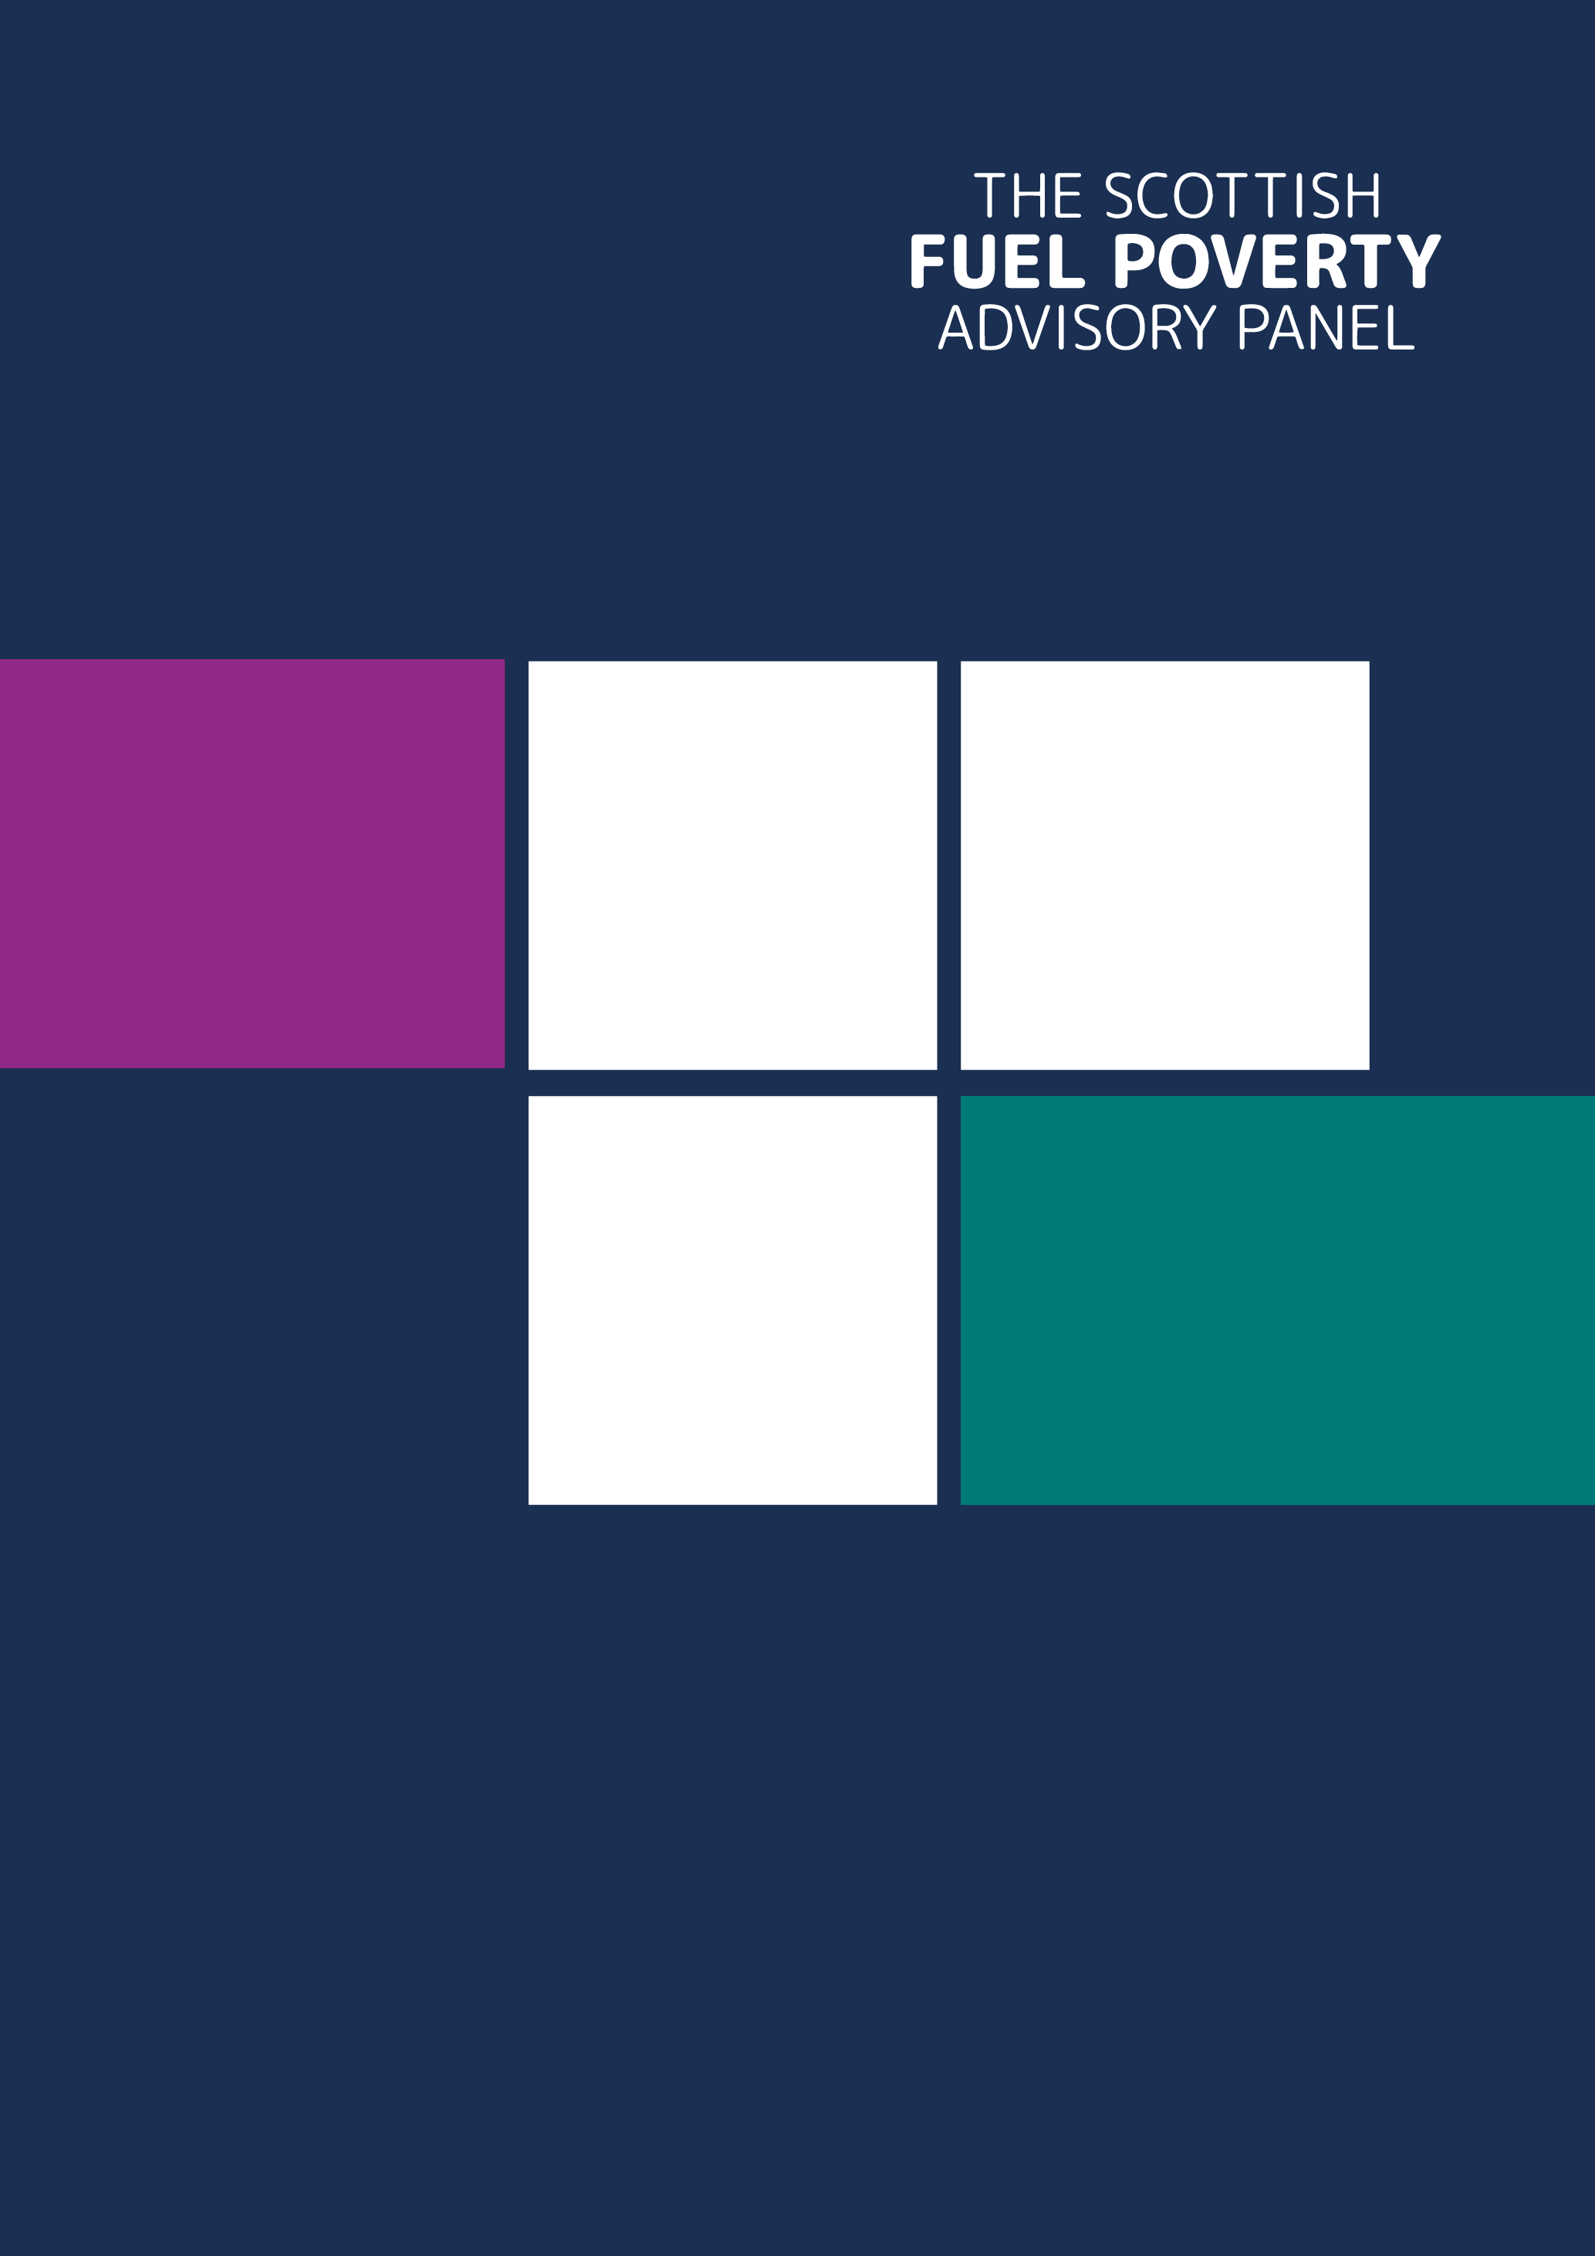


April 2026 – March 2027
Workplan
Contents
Introduction 3
2026-2027 Workplan 6
1. Advise Scottish Ministers on the revision of Tackling Fuel Poverty, a Strategic Approach 7
2. Complete our work on the drivers of fuel poverty in rural and remote communities, particularly island communities. 8
3. Explore innovation where interventions may lead to a reduction in energy costs. 8
4. Complete our work on the co-benefits of tackling fuel poverty and improving public health outcomes. 8
5. Building on our understanding of health outcomes for those in fuel poverty, we will bring an intersectional lens to understanding households’ risk of fuel poverty. 8
6. Other Priorities 9
Annex A: our work themes mapped against our seven strategic goals 11

Introduction

The 2024 Scottish House Condition findings show a welcome reduction in fuel and extreme fuel poverty rates with fuel poverty falling to 28.7% (around 732,000 households), down from 33.9% in 2023, with 14% of all households (357,000) in extreme fuel poverty down from 19.4%. This is mainly attributable to falling energy prices in 2024. However, as the recent 13% energy price cap rise shows, energy prices are rising again in response to the energy shock caused by the crisis in the Middle East. A further 2% rise on the July-September cap is predicted for the October-December quarter. Energy debt and arrears also continue to rise, Citizens Advice Scotland report that in the first quarter of 2026, a total of £2.7 million of energy debt was brought to their network. Fuel poverty remains deeply rooted in Scotland’s communities.

This workplan year will be an important one in setting the direction for fuel poverty policy and programmes as the new Scottish Government works to revise its Fuel Poverty Strategy, due to be published in December 2026. It is probable that this year’s programme for government from the Scottish Government will also set a timetable for the introduction of the Buildings (Heating and Energy Performance) and Heat Networks (Scotland) Bill. Our key priority for this workplan year will be to offer Scottish Ministers advice on the Fuel Poverty Strategy revision. We will do this by continuing the work we began with our response to the Scottish Government’s Periodic Report last year, setting out a framework for a revised Strategy, and will revisit the advice we have given to Scottish Ministers to date to ensure it reflects the current fuel poverty landscape. We will also advocate for fuel poverty to be explicitly recognised in the Buildings (Heating and Energy Performance) and Heat Networks (Scotland) Bill. We will offer recommendations for the revised Strategy which have emerged from our work on the impact of fuel poverty drivers on island communities and strengthening health and fuel poverty policy links. Our work on health and with island communities has highlighted the intersectional nature of fuel poverty where several factors come together to cause, or deepen, people’s fuel poverty. We want to understand further what the work in this area has shown, shine a light on findings, identify data gaps and suggest how policy and fuel poverty approaches, programmes and projects, could be strengthened by bringing an intersectional perspective to them.

The energy transition is moving at pace but is complex and achieving a synchronised transformed energy system is the work of many years. Separate moving parts lead to unintended consequences such as poor grid connectivity resulting in high curtailment costs with currently limited benefit to consumers in Scotland. Much is happening at a strategic policy level as REMA moves to Reformed National Pricing but the challenge of reducing energy prices remains immediate. We know that electricity prices in particular cause entrenched fuel poverty in areas where electric heating is the norm and unregulated fuels prevalent – typically rural and island communities. The price cap can mask the true reality of energy bills for those using electric heating systems. The lived experience of those contending with high electricity prices and greater consumption needs with electric heating systems has been brought home to us again in our recent work on the impact of the fuel poverty drivers on Scotland’s island communities. The price cap does not cover the costs of alternative (unregulated) fuels either where volatile pricing is a challenge for those who depend on them for heat. The sudden and dramatic rises in the cost of oil following the crisis in the Middle East, has seen the UK Government allocate funding to alleviate the full impact on vulnerable consumers . Funding which the Scottish Government augmented and opened up to those using LPG. The ongoing uncertainties in the energy markets will increase fuel poverty rates as energy prices are rising again as we have seen with the recent price cap increase and the anticipated further rise in October. In spite of this, there is innovative practice throughout Scotland, which is proving that even with high energy prices, there are solutions which can be deployed to reduce energy bills and mitigate fuel poverty. We will be exploring these solutions and the impact they can have in reducing fuel poverty.

The UK Government is planning to introduce reforms which should bring down the price of electricity but when and how long before these take effect is unclear. Earlier this year the UK Government published the Fuel Poverty Strategy for England. With its shift to affordability, and the funding underpin for the Warm Homes Plan which will help deliver it, additional financial consequentials will flow to Scotland. As energy price crises are becoming more frequent and prolonged, the need for fuel poverty policy to move beyond short-term emergency response towards long-term resilience increases. The Warm Home Plan financial consequentials create opportunities to scale and speed up energy efficiency improvements in Scotland – poor energy efficiency being the fuel poverty driver where the Scottish Government has the most leverage.

We will, as in previous years, engage and collaborate widely accepting invitations where we can. We will also continue to nurture connections, in partnership with others, across the fuel poverty landscape.

Who we are
The Panel is an independent advisory Non-Departmental Public Body (NDPB), established under The Fuel Poverty (Targets, Definition and Strategy) (Scotland) Act 2019, set up to support Scottish Ministers and others to help eradicate fuel poverty in Scotland.

We have six panel members. Five members are contracted to work around 12 days a year with the chairing member working around 18 days a year, collectively working a maximum of 90 days. Our appointments run until the end of December 2029. We are supported by a Secretariat of three.

What we do
The Panel provides an independent voice to Scottish Ministers on fuel poverty matters, fostering co-operation across the fuel poverty landscape, and fulfilling its statutory duty of monitoring Scottish Ministers’ progress towards meeting Scotland’s statutory fuel poverty targets, as well as advising Scottish Ministers on emerging fuel poverty issues. This includes assessing the likelihood of the Scottish Government meeting those targets, how the four drivers of fuel poverty are being addressed, and how effectively the implementation of Scotland’s Tackling Fuel Poverty Strategy, programmes and projects are working to deliver Scotland’s fuel poverty targets and address the fuel poverty drivers.

Our March 2024 to April 2027 Strategic Plan sets out our strategic goals which underpin our vision and mission for this three-year period.


The Panel’s vision is for:
A Scotland where everyone lives in an energy efficient home and has access to affordable clean energy – a Scotland where no one lives in fuel poverty.

The Panel’s work is driven by its mission to:



Strengthen fuel poverty policy, legislation, and practice
in Scotland and the UK.
Eradicate fuel poverty and increase resilience by engaging
with people with lived experience and those who support them.
Advise Scottish Ministers, scrutinising progress,
and advocating for action.

The Panel’s principles for all our work are:
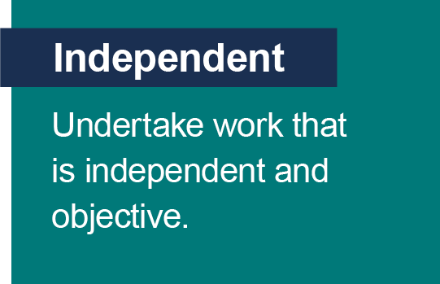
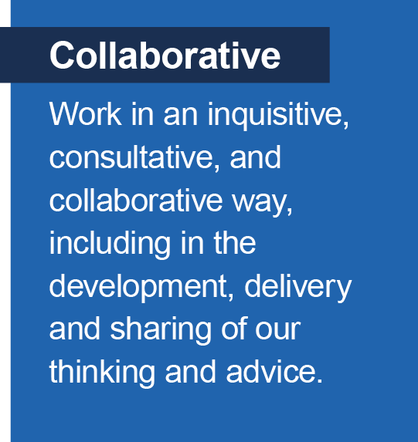
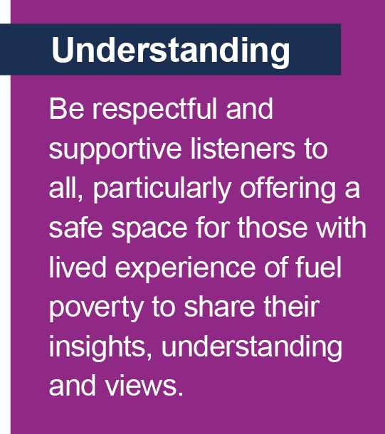
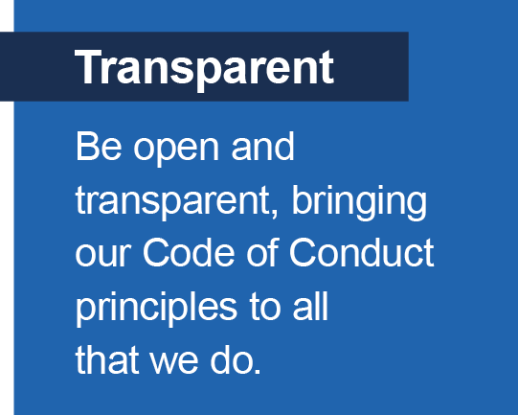
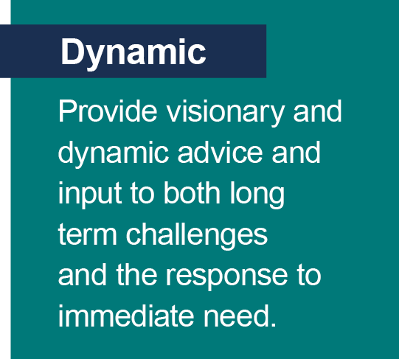
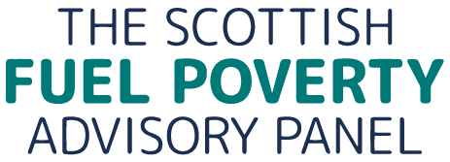

Our workplan is also shaped by our seven strategic goals:

- We will advocate for the eradication of fuel poverty by relationship building, and through evidence-based policy development and delivery in Scotland, and in the UK where appropriate

- We will be informed by evidence from a wide range of sources and stakeholders, including those with lived experience and the organisations that support them

- We will offer insights and reflections to support Scottish Government to improve short-term and long-term responses to Scotland's shifting fuel poverty landscape

- We will provide an independent view of Scottish Government’s progress towards and likelihood of achieving Scotland’s statutory fuel poverty targets

- We will advocate for actions and solutions to address the drivers of fuel poverty across, and in line with, all the relevant policy areas which contribute to National Performance Framework outcomes

- We will champion and foster a collaborative approach to challenging fuel poverty drivers and other structural causes, identifying and encouraging actions to address fuel poverty with stakeholders across the public, private and third sectors

- We will establish and maintain a strong values-led governance framework to ensure the effectiveness of the Panel.

Annex A shows how the work we have planned maps to our strategic goals.

2026-2027 Workplan

Our April 2026 to March 2027 workplan sets out our priorities for the year. The Panel’s key priority this year is to fulfil its statutory consultee role, advising Scottish Ministers on their revision of Tackling fuel poverty in Scotland: a strategic approach which is due to be revised by the end of December 2026.
Our core priorities are to:
- Advise Scottish Ministers on the revised Fuel Poverty Strategy – as required by provision 7 of the Fuel Poverty (Targets, Definition and Strategy) (Scotland) Act 2019, by the end of 2027.

- Complete last year’s exploration of the drivers of fuel poverty in rural and remote communities, particularly island communities.

- Build on the evidence gathered on fuel poverty in island communities by considering innovations and interventions which may lead to a reduction in energy costs across Scotland

- Complete our work exploring the health outcomes for those in fuel poverty.

- Expand on our health theme by adopting an intersectional approach to fuel poverty risk, recognising that overlapping health, social and economic vulnerabilities influence both exposure to fuel poverty and the effectiveness of policy responses.
We will also continue to:
Embed lived experience
Embed the voice of lived experience throughout our work, through direct engagement with lived experience panels and in partnership with the organisations that support and advocate alongside them.
Advocate
Advocate for the introduction of a flexible energy discount mechanism, highlighting the opportunity this offers to reduce and potentially even close the fuel poverty gap. We will do this by:
- Continuing to work with the Scottish Government as a member of their Energy Social Tariff Working Group and continuing to influence the UK Government on the introduction of a flexible discounted tariff. The Panel recognises that it is the UK Government who have the fiscal and policy levers to introduce a tariff, particularly should the UK Government consult/bring forward an energy bill support scheme in the light of the new energy price shock caused by the crisis in the Middle East. As we noted in our workplan last year in commenting on the 2023 fuel poverty figures, even with market interventions and unprecedented consumer energy support, governmental programmes and projects, these were not enough to reduce fuel poverty rates to the pre-2022 energy crisis rate. This shows how difficult and complex it is to resolve fuel poverty and makes targeted and sufficient interventions essential.
- Continuing to draw attention to the need for fuel poverty mitigation to feature as a measurable objective within wider net zero policies – including contributing our thinking to the Scottish Government’s Buildings (Heating and Energy Performance) and the Heat Networks (Scotland) Bill as it is introduced and progresses through the new parliamentary session.

Seek to influence:

- Ofgem in shaping a retail market which works for all consumers and responds to the needs of vulnerable consumers in or at risk of fuel poverty.
- The UK Government in their ongoing work to reform the energy system by responding to relevant consultations within our capacity to do so, which impact energy affordability for vulnerable consumers, including as noted above, any new energy bill support schemes. .

Work on:

- Emergent priority fuel poverty issues in a changing operating environment.
Engage with:
- Consumer Scotland on their workstreams on reducing consumer harm and advancing inclusion, fairness, prosperity and wellbeing. This includes feeding in to standing charge consultations where useful, following CS advocacy for DESNZ and Ofgem to revise distribution charging arrangements.
- The Committee on Fuel Poverty to share ideas and learning and discuss opportunities to align with and where relevant, connect with, the Fuel Poverty strategy for England and the Warm Homes Plan.

1. Advise Scottish Ministers on the revision of Tackling Fuel Poverty, a Strategic Approach

In September 2025, we fulfilled out statutory role of responding to the Scottish Ministers publication of the first of their triennial periodic reports, Tackling fuel poverty in Scotland: periodic report 2021-2024 (published on 1st April 2025, as stipulated by the Fuel Poverty (Targets, Definition and Strategy) (Scotland) Act 2019). In preparing our response, we also took into account the findings and recommendations from our periodic report consultation response and other’s consultation responses where these were published.
We made a number of recommendations with our views on how a revised Fuel Poverty Strategy should be framed. We recommended that a revised strategy should:
- Include a delivery and resource plan, be produced in consultation with key stakeholders, and should be in place by December 2026.
- Have a clear governance structure to oversee the delivery plan, and a monitoring and evaluation framework allowing its impact on progress towards the targets to be measured.
- Set out the policy co-dependencies with other Scottish Government statutory targets – Child Poverty, Climate Change and Heat Networks’ output – to show how they are contributing to meeting fuel poverty targets.
- Make clear the strategic approach to influencing on reserved issues as part of the delivery plan.
- Be underpinned by a research approach which supports the weighting of the different fuel poverty drivers and to inform understanding of fuel poverty experience.
Our recommendations set out a framework for the revision of the Fuel Poverty Strategy. In supporting the development of this framework, we will:
- Respond to specific requests for advice from the Scottish Government on the shaping of the Fuel Poverty Strategy and how the evolving monitoring and evaluation framework can develop further. (We note also that the Fuel Poverty (Targets, Definition and Strategy) (Scotland) Act 2019, paragraph 6, sets out parameters for reviewing the Strategy).
- Offer advice based on engagement and research which we undertook during our 2025-2026 work on the systemic impact of fuel poverty in rural and remote areas and considering the impact of fuel poverty on public health. In particular, we will make recommendations on how the revised Fuel Poverty Strategy should reflect the needs of rural and remote communities, and island communities in, drawing on the Island Fuel Poverty Roundtable which we held in March 2026., We will also focus on how improving health outcomes should be recognised as a core objective of the revised Strategy, rather than a secondary benefit of fuel poverty reduction.
- We will offer our thinking to the Scottish Government on the efficacy of direct bill support versus cash payments in supporting those in, or vulnerable to, fuel poverty and how this can support policy alleviation measures and contribute to meeting the fuel poverty targets. This follows our testing of this question with stakeholders across the fuel poverty landscape in the last quarter of our 25-26 workplan.
- In 2024, our Social Researcher undertook a review of the Scottish fuel poverty funding landscape which informed a set of funding principles and recommendations. Ongoing engagement since their publication, including with island communities, has reinforced the continued relevance and validity of these principles and recommendations. Changes to the funding landscape with the Barnett financial consequentials, which will flow from the UK Government’s funding commitment to deliver the Warm Homes Plan and the ending of the Energy Company Obligation Scheme bring opportunity and challenge. Our Social Researcher will update our 2024 fuel poverty funding landscape review, and we will offer reflections on this. Following the funding landscape update, we will offer our views on the funding opportunities and challenges.
- As the Scottish Government works to revise the Fuel Poverty Strategy, we will revisit the advice we have given to Scottish Ministers since our first Members were appointed in 2022 and revise them as necessary in the light of changes to the fuel poverty landscape over the last 4 years.
- We will make clear in our advice to Scottish Ministers how action on fuel poverty can support the Public Service Reform pillars of prevention, joined up services and efficient services.
Scottish Ministers’ timetable for revising the Fuel Poverty Strategy will determine how much time we are able to devote to our other workplan themes, and we will routinely review what we are able to deliver throughout the year.

2. Complete our work on the drivers of fuel poverty in rural and remote communities, particularly island communities.

Our work on fuel poverty in island communities followed on from a literature review of rural fuel poverty and work we commissioned on the lived experience of rural fuel poverty. We engaged individually with the six local authorities with responsibility for island communities in February, followed by an island fuel poverty roundtable in March.
We will:

- Publish a report on the findings of our evidence gathering on fuel poverty in the island communities.
- Make recommendations to the Scottish Government on addressing the embedded high levels of fuel poverty in island communities in the revised Fuel Poverty Strategy and implementation of existing programmes.

3. Explore innovation where interventions may lead to a reduction in energy costs.

We recognise the profound challenge of energy system transformation, but the high energy prices associated with the current energy system, the costs to consumers of transitioning to a new one and geo-political factors are exacerbating fuel poverty. There are, however, local, and place-based innovations which are mitigating and preventing fuel poverty. Reflecting on our work on fuel poverty solutions with rural and remote stakeholders, we will explore innovative practice where interventions have led to a reduction in energy costs, or where there is the potential for innovation to achieve lower energy costs. We will consider where the barriers and opportunities lie in scaling up innovation practice.
We will, within the limitations of our small budget:
- Commission research, either externally or through our Social Researcher to better understand the range and scale of emerging innovations, and what existing evaluation evidence indicates about their effectiveness in reducing energy costs.
- Visit a range of these innovations to hear directly from those involved in delivering them, as well as from the people and communities benefiting from them.
- Bring those involved in different innovative projects together in a roundtable to explore how the fuel poverty driver of higher energy prices can be mitigated, in spite of the wider system challenges and geo-political factors, to alleviate fuel poverty.
- Offer advice to Scottish Ministers on our findings.

4. Complete our work on the co-benefits of tackling fuel poverty and improving public health outcomes.

As part of our work exploring the relationship between fuel poverty and health outcomes, we commissioned research examining the interaction between fuel poverty and public health policy within the Scottish Government. The findings demonstrate that, at present, these policy areas remain insufficiently connected. Following on from the research, further work will be undertaken to identify relevant case studies.
We will:
- Publish this research alongside case studies demonstrating where action to reduce fuel poverty has also delivered measurable health benefits.
- Make recommendations to the Scottish Government on how a stronger public health approach can be embedded within the revised Fuel Poverty Strategy.

5. Building on our understanding of health outcomes for those in fuel poverty, we will bring an intersectional lens to understanding households’ risk of fuel poverty.

We have previously highlighted the intersectional nature of fuel poverty, recognising that a household’s risk is often shaped by multiple overlapping vulnerabilities, including health, age, disability, income, housing circumstances and family context. Our work exploring the interaction between fuel poverty and public health policy suggests that adopting a more intersectional approach could lead to wider co-benefits and improved outcomes across a range of policy areas. We therefore want to build a stronger understanding of what existing evidence and practice in this area can tell us, highlight effective approaches, identify key evidence and data gaps, and explore how policy and fuel poverty approaches, programmes and projects, could be strengthened by the more consistent application of an intersectional lens.
We will:
- Commission a literature review exploring how overlapping vulnerabilities shape the risk and experience of fuel poverty, and how an intersectional approach could strengthen policy and interventions.
- Engage with experts by experience to hear their reflections.

6. Other Priorities

We will continue to use our resources as effectively as possible by working responsively, flexibly, and proportionally so that we can react to, and offer our thinking on, emerging fuel poverty issues. Alongside our work on the revised Fuel Poverty Strategy, we will continue to fulfil our scrutiny and advisory obligations as required. We will work with the Scottish Government to review our Framework Agreement, develop our next Strategic Plan following the publication of the revised Fuel Poverty Strategy, and support the effective integration of our newly appointed Panel Members as the Panel moves into its next four-year term at full complement.
Scrutiny and Advice
- We will continue to support Scottish Government as it works to revise the Fuel Poverty Strategy and develop a monitoring and evaluation framework.
- We will engage with Scottish Government officials to offer our views on the eligibility criteria for the next round of Warmer Homes Scotland during the first quarter April 2026 – June 2026.
- We will participate in any further planned Ministerial Social Tariff Working Group meetings.
- We will engage with Scottish Government statisticians to discuss the Scottish House Condition Survey, including the implications of the Local Authority breakdown once published.

Governance
- We will review this April 2026 – March 2027 Workplan once the Scottish Government’s timetable for revising the Fuel Poverty Strategy is clearer to ensure our priorities remain aligned.
- We will publish our third Annual Report (April 2025 to March 2026) covering the last year of our operation in summer 2026.
- We will work with the Scottish Government to revise our joint Framework Agreement.
- Following the publication of the revised Fuel Poverty Strategy, we will develop a new Strategic Plan exploring the potential for this to operate on a 4-year cycle to align with the current Panel’s appointment term.
- We will agree a workplan for April 2027- March 2028 by March 2027.
- We will re-procure our website and communication contracts as the current contracts end to ensure the Panel's work remains visible, accessible, and transparent.
Collaboration and engagement

- Collaboration and engagement are embedded in the way we work and will always underpin our workplan. Engagement with those with lived experience of fuel poverty is critical and we will explore new avenues to collaborate in bringing the lived experience voice to our work. We routinely seek to engage with central and local government, parliamentary committees, third sector organisations, the regulator, and organisations in the energy sector, and will continue to do so including with other public bodies where there is a shared interest in fuel poverty and its wider impacts.
- We will seek to engage with the Scottish Government on the Draft Buildings (Heating and Energy Performance) and Heat Networks (Scotland) Bill, assuming this is introduced, to ensure that the bill supports tackling fuel poverty.
- In the context of yet another energy shock and the dynamic environment of the energy transition we will engage where appropriate with, Ofgem and the Department for Energy and Net Zero as they work on Reformed National Pricing to highlight the impacts for those in, or on the edge, of fuel poverty.
- We will attend the annual Scottish Federation of Housing Association annual conference which brings together Scotland’s social housing sector. We will contribute our reflections on progress made through Scotland’s Fuel Poverty Strategy to date the ongoing challenges facing households and providers and the opportunities to accelerate progress towards warmer homes and lower energy costs.
- We will attend the annual Energy Action Scotland conference which brings together the fuel poverty stakeholder community across Scotland in the Autumn.
- Continuing our work to broaden our understanding of the fuel poverty research base, our Social Researcher, in collaboration with Consumer Scotland, will run a second network event to understand and disseminate current research underway across Scotland. In support of this, our Social Researcher will attend the Energy Poverty Research Network 27-28th October.

How we will monitor the delivery and success of this plan

- Delivery – at the time of publication, we intend to meet in-person four times over the lifetime of this plan (April 2026 to March 2027), with several additional online meetings as needed to deliver our workplan. These meetings will be used to review progress against the workplan, monitor delivery and adjust priorities where necessary , including a more formal review once the Scottish Government approach to the revision of the Fuel Poverty Strategy is clear.
- Success – we will monitor the success of this plan by continuing to develop indicators to evaluate the effectiveness of this plan. We recognise that for a small organisation it is critical that the approach to this is proportionate. In developing our next Strategic Plan, we will take the learning from our monitoring of the first plan to ensure a pragmatic approach.
We welcome comments on this plan and approaches for engagement and or collaboration – enquiries@fuelpovertypanel.scot

Annex A: our work themes mapped against our seven strategic goals

 | Workplan themes | Strategic Goals
 |  | Advocate for the eradication of fuel poverty by relationship building, and through evidence-based policy development and delivery in Scotland, and in the UK where appropriate. | Be informed by evidence from a wide range of sources and stakeholders, including those with lived experience and the organisations that support them. | Offer insights and reflections to support Scottish Government to  improve short-term and long-term responses to Scotland's shifting fuel poverty landscape, | Provide an independent view of Scottish Government’s progress towards and likelihood of achieving Scotland’s statutory fuel poverty targets. | Advocate for actions and solutions to address the drivers of fuel poverty across, and in line with, all the relevant policy areas which contribute to National Performance Framework outcomes. | Champion and foster a collaborative approach to challenging fuel poverty drivers and other structural causes, identifying and encouraging actions to address fuel poverty with stakeholders across the public, private and third sectors. | Establish and maintain a strong values-led governance framework  To ensure the effectiveness of the Panel.
1. | Advising Scottish Ministers on the revision of Tackling Fuel Poverty, a Strategic Approach | ü | ü | ü | ü | ü | ü
2. | We will explore innovation where interventions lead to a reduction in energy costs. | ü | ü | ü | ü | ü | ü
3. | Building on our understanding of health outcomes for those in fuel poverty, we will bring an intersectional lens to understanding households’ risk of fuel poverty. | ü | ü | ü | ü | ü | ü
4. | Other priorities | ü | ü | ü | ü | ü | ü | ü

Scottish Government (2026) Scottish House Condition Survey: 2024 Key Findings - gov.scot.
Ofgem (2026) Energy price cap announcement.
Cornwall Insights (2026) Energy Bills Set to Rise in July, as Forecasts Warn October Could Be Worse.
Typical Domestic Consumption Values used in calculating the price cap are unrepresentative for those using electric heating as their main heat source. And whereas 98% of those in urban areas are within coverage of the gas grid, 57% of those living rurally cannot and therefore must use electric heating or alternative fuels.
Scottish Government (2026) Support for households using heating oil and LPG - gov.scot
UK Government (2026) Over £50 million to help families struggling with soaring heating oil costs - GOV.UK
UK Government (2026) Decisive action to break influence of gas on electricity prices - GOV.UK.
House of Commons Committee of Public Accounts (2025) Energy Bills Support

