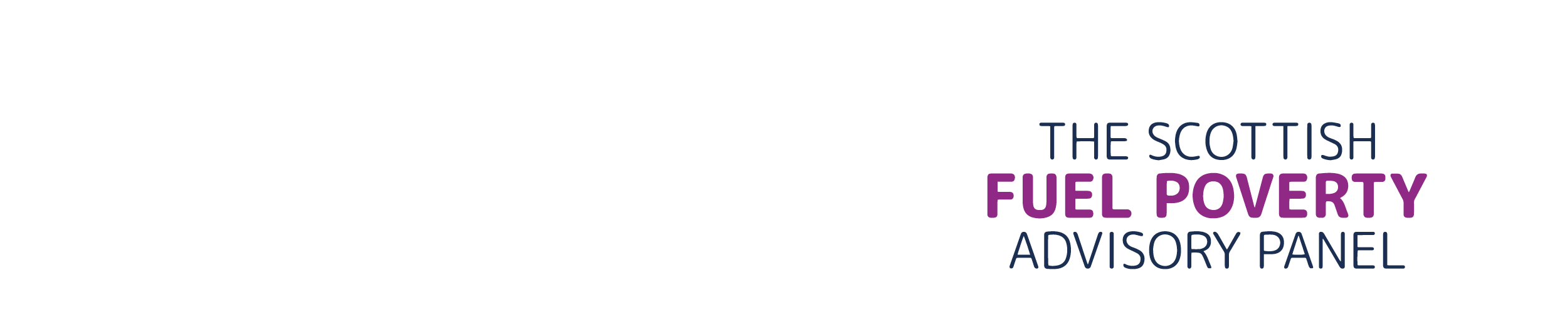


Minutes of Meeting on 25th September 2025
Venue: Online via Teams
Time: 12:00–14:00
Type: Panel


Attendees
Panel: Matthew Cole, Kirsten Jenkins, Alister Steele and Fraser Stewart
Secretariat: Roanna Sefton and Trisha Melvin

Agenda item 1: Introductory Remarks
Matt welcomed everyone to the meeting, noted Philippa was on annual leave and ran through the agenda.
Agenda item 2: Update on Intern
Roanna gave an update to the intern. Roanna advised the Panel that they will have 2 new interns starting: one a PhD student at the University of Edinburgh, and the other at Glasgow University. Both interns will be full time for 13 weeks. Roanna advised that the interns will probably now start in mid-November and finish in mid-February. Roanna advised she will need to pull together project initiation documents and will hold a separate meeting with Kirsten to get help with this. Roanna spoke to the Panel about the two project ideas, with one focusing on policy mapping and the other looking at case studies that combine health and fuel poverty approaches. The Panel endorsed these two projects.
Agenda item 3: EAS Conference Paper
Trisha went over the costings for the Energy Action Scotland (EAS) conference which is taking place in November on 20th and 21st in the Golden Jubilee Hotel. The Panel had a discussion on who can attend and when. They asked Trisha to follow up with an email and up-to-date costings but agreed they would be attending.
Agenda item 4: Roundtable Discussion
Roanna spoke to the Panel about holding the previously mooted Roundtable on solutions to rural fuel poverty ahead of the EAS conference. Roanna advised the Panel that her understanding is that they would follow the model of the previously held Heat Networks Roundtable. The Panel spoke about the objective of the meeting and who should be invited. The Panel discussed where to hold the session in order to facilitate the attendance of those travelling to the EAS Conference. The Panel agreed to run a session with third sector organisations on the 19th November, lasting around two hours with a focus on discussion rather than presentation. They also agreed that they might want to have a separate session looking at community benefits or locally owned energy, with a focus on the role of local authorities. Roanna will send an email out to the Panel with a list of organisations to choose from for the meeting on the 19th November.
Agenda item 5: AOB
Recruitment Update: Matt gave an update on the recruitment of two new panel members. He advised that there has been a large number of applicants and that interviews would hopefully take place in November and new Panel members would be appointed by the start next year.
Stakeholder List: Alister suggested asking some stakeholders to share the Periodic Report Response with their members, in order to maximise the dissemination of the report. This was agreed by the Panel and the Secretariat took away this action. Trisha also covered off the draft email template she would use to send out the Periodic Report Response to stakeholders.
Ofgem Standing Charges Consulation: Fraser flagged a new Ofgem consultation on standing charges and asked if anyone had more information. Matt briefly described his understanding of the consultation and told Fraser he was happy to have a separate conversation if needed.
Agenda item 6: Panel reflection
Matt invited reflections and then closed the meeting.
Next meeting – 20th of October 14:00-16:00 online.

