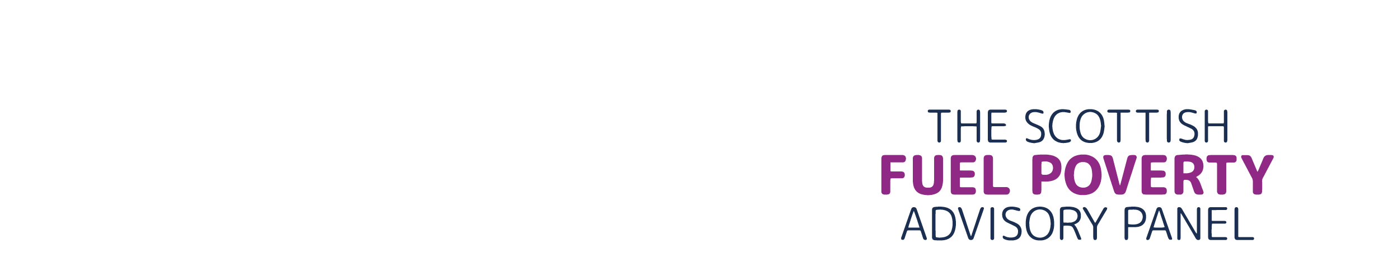


Minutes of Meeting on 20th October 2025
Venue: Online via Teams
Time: 14:00–16:00
Type: Panel


Attendees
Panel: Matthew Cole, Kirsten Jenkins, Alistir Steele and Fraser Stewart
Secretariat: Philippa Brosnan, Roanna Sefton and Trisha Melvin

Agenda item 1: Introductory Remarks
Matt welcomed everyone to the meeting and ran through the agenda.
Agenda item 2: Extending the Warm Home Discount Consultation Scheme Brief (Department of Energy and Net Zero) consultation

Philippa shared a presentation outlining the options for responding to the WHD consultation, which opened on 25th September and closes on 20th November. The Panel considered the options for Scotland which DESNZ are consulting on and discussed these and how the extent to which they fit with the Panel’s advocacy for a flexible energy discount mechanism (or social tariff). The Panel agreed that it would respond to a selection of the most relevant questions. Engagement with DESNZ would be useful as would exploring the views of other organisations to see how these compare with the Panel’s thinking.

Philippa will take forward the points raised during the discussion and will report back on findings by the 6th November.

Agenda item 3: Scoping of bill versus cash fuel poverty impact

Roanna set out the rationale for a direct bill support versus cash approach in the Scottish Government’s Analytical Index which informed the Tackling Fuel Poverty a Strategic Approach. An initial look at other research has not unearthed much in the way of complementary direct bill support research. Many organisations have a cash first presumption to support people’s dignity and power of choice.

In discussion, the Panel agreed that Roanna would draft questions to send to relevant organisations seeking their experiences and views on the efficacy or not of different approaches to supporting those in, or on the edge, of fuel poverty, touching specifically child poverty payments, housing payments, and fuel payments.

Agenda item 4: Energy Action Scotland Conference, Matt’s presentation to CPW group and reflections on the reception of the Periodic Rreport Response to date
Philippa noted that Energy Action Scotland has confirmed that it is interested in a presentation on the Panel’s Periodic Report Response (PRR) at its conference. The session in which the Panel presents will include an discussion focused on affordability.
The Panel agreed that if Matt is unavailable to speak, Alister will step in as his replacement.
The Secretariat were tasked with organising the presentation slides and a summary of key points.
Philippa further advised that there have been 12 media mentions of the PRR, including 2 radio bulletins. The Panel agreed that the Secretariat should engage with the relevant Scottish Parliament Committees on the PRR.
Agenda item 5: National Audit Office (NAO) Report
Matt noted the National Audit Office’s publication on the Energy Company Obligation (ECO).
The Panel discussed the report’s findings, focusing on its implications for individuals and associated costs. The Secretariat were asked to explore what the picture is for energy efficiency installations for the Scottish Government funded schemes.
Agenda item 6: Panel reflection
Matt invited reflections and then closed the meeting.
Next meeting – 26th of November 10:00 – 16:00 at AQ5, Glasgow.

