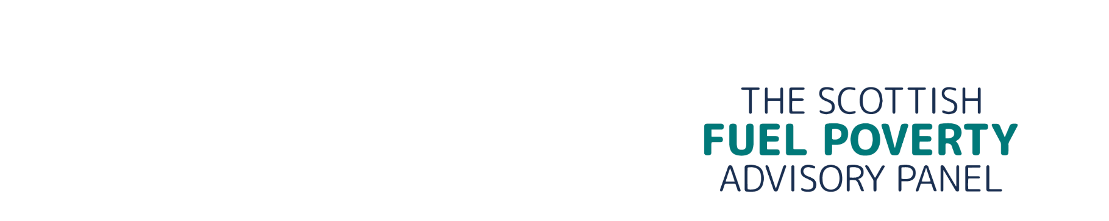

Chair of the Scottish Fuel Poverty Advisory Panel
E: philippa.brosnan@fuelpovertypanel.scot, roanna.simpson@fuelpovertypanel.scot & trisha.melvin@fuelpovertypanel.scot

14 November 2024
To: Dr Alasdair Allan, MSP, Minister for Climate Action
Cc: Gillian Martin MSP, Cabinet Secretary for Net Zero and Energy, Fuel Poverty Policy Officials

Scottish Fuel Poverty Advisory Panel’s response to your invitation to comment on the progress (periodic) report to be laid before the Scottish Parliament in 2025
Dear Minister

Thank you for your invitation to comment, and offer the Panel’s reflections, on the progress report to be laid before the Scottish Parliament in 2025.

As you know, the Scottish Fuel Poverty Advisory Panel (SFPAP) will have been established for three years in January 2025. It is a micro Non-Departmental Public Body with 3 full-time staff delivering a secretariat service and with Panel members collectively serving around 75 days per year.

We welcome the opportunity to provide feedback and reflections to aid the production of the Scottish Government’s first Periodic Report on progress made towards meeting the fuel poverty targets. Our scrutiny of the Periodic Report and what we say here will build upon what we have shared formally and in bilateral meetings with Ministers and Scottish Government officials. There shouldn’t be any surprises, and we don’t ever plan to blindside Ministers or Scottish Government officials. Collaboration is key. At present we do not plan to publicly release our input to you. That said, from a transparency perspective we are happy for this to be shared as part of the Periodic Report process as agreed with Ministers and Scottish Government officials.

We recognise that fuel poverty is a hard, complex, and longstanding issue to resolve. We also recognise that an Act and a Strategy, and the ambition that comes from these, should provide some focus and direction and a framework that policy and proposals can be measured against. We acknowledge, too, that the Strategy was developed during the pandemic and was then executed as the cost of living and energy crises gathered pace and so very much started in unusual times and has continued that way.

Of the four key drivers of fuel poverty in Scotland, household income and energy prices have had the greatest impact, and as energy prices have increased significantly above pre-pandemic levels whilst incomes have been squeezed, we have seen fuel poverty levels (as measured through the Scottish House Condition Survey) track upwards too. Behind every increasing statistic there is a real person or family: the pensioner couple in Argyll who are struggling to afford and so struggling to maintain optimum levels of household heat; the young family from Glasgow who live in drafty and damp housing where fuel poverty is one of the many issues being juggled on a daily basis. The support worker who is struggling to close the gap when there are no solutions readily available that will work. We have engaged widely and have placed listening at the heart of what we do, and our thinking is informed by the conversations we have had.

Although we recognise that these two levers - high energy prices and low incomes - remain as reserved matters and so Scottish Ministers’ roles here may be somewhat restricted at times, devolved policy around heat strategy and certain elements of social security does and can have some impact and provide some mitigation to the immediate and long-term effects of being in fuel poverty.

Therefore, it is the Panel’s opinion that to strategically assess progress in achieving Scotland’s fuel poverty ambition some principles are important to ground:

- There needs to be transparency around the assumptions that were used in the development of the strategy, that details how the 55 actions would contribute to the targets enshrined in law. This would also include details of where the strategic actions were unknown – and for a strategy and vision that stretches over 20 years it would be expected that not all actions would be known from day one.

- A monitoring and evaluation framework that details how progress is being made against the actions is essential – in both ensuring early sight of any issues or opportunities, but also to provide a foundation upon which an informed assessment of performance and inter-dependencies and likely outcomes can be made.

- A robust governance structure is needed to drive progress and actions – in particular, when complex strategy cuts across many policy areas and or delivery units or functions, and stretches over many years, or indeed in areas of high levels of change, be it technological, societal or economic.

The above are essential because they ensure that any feedback and opinions or discussions are grounded in fact, in data, and remain objective. And so, without a monitoring and evaluation framework, that provides an objective commentary or assessment on progress, it is impossible to draw any hard conclusions on the impact of interventions and activities. As such, we, the Panel, can only make the following comments based on what we have seen and heard:

- We see and appreciate the work today on the monitoring and evaluation framework and urge that this is used as an enabler to consider how enhanced governance protocols can be implemented that would in turn drive a greater cross-Governmental focus on fuel poverty. The near absence of any prioritisation or mention of fuel poverty in the Programme for Government appears to place fuel poverty in a secondary position to other poverty-related policies, such as child poverty. We have stated our view before that child poverty cannot be tackled without also tackling fuel poverty.

- We worry about the increasing proportion of families who find themselves in extreme fuel poverty and how the interventions that are needed to lift them out of fuel poverty altogether will be complex and need to address multiple drivers. A decent quality home in itself does not necessarily mean that people are removed from fuel poverty, which in previous years was more of a certainty.

- We note the progress being made to improve quality of housing stock across Scotland and note the increasing proportion of homes that are rates A-C from 45% in 2019 to 52% in 2022. We see the potential that can be realised from the Heat and Buildings Strategy and the contribution that this could make to helping achieve some of the statutory targets in the run up to 2040.

- We recognise that the current Strategy has been overtaken by events, and that a full review is needed, but also that a mid-term prioritisation of some of the strategic actions might have provided increased clarity and focus on those actions that would have had the maximum impact.

- We recognise the financial challenges around the current budgetary settlement and the tough decisions that can come from this. We also note that to fully address fuel poverty a number of tactical or crisis and strategic interventions are needed, and both should be recognised as important. An over-focus at either end of the scale can result in unintended consequences and it is important to ensure that both are given similar footing i.e. we will support people living in fuel poverty today whilst working on and then implementing the optimum strategic solution that will address some or all of the drivers of fuel poverty. The Warm Homes Prescription trial is a useful example of where a focus on longer term better health outcomes has provided immediate support to keep warm today, enabling those involved to embrace the energy efficiency measures which will help keep them warm tomorrow.

- We note the focus of Scottish Ministers in influencing their UK counterparts on the importance of specific reserved interventions, for instance the introduction of a wider social tariff and would champion wider collaboration across all nations of the UK where there are areas of commonality or potential for them. It is critical that Scottish voices are heard and are visible when UK policy is being developed.

- We are struck by the reality faced by many who live in remote rural or island communities who rely on unregulated fuels, or electricity (but not mains gas) for heat and hot water, and the associated costs that are incurred here, alongside at times the absence of decarbonisation solutions that would also reduce total home heating cost.

- We recognise the real passion to address fuel poverty, across local and national government, the third sector and the wider sector too. All recognise that wider impact that being in fuel poverty has, and the opportunities that removing the risk of fuel poverty will present. Solving fuel poverty in itself isn’t a tough sell - hearts and minds are already there. A re-focussed Strategy that concentrates on the key enablers that address the drivers of fuel poverty in Scotland, will provide the leadership and vision needed as we move to within 15 years of the Statutory target date.

We look forward to continuing to work with you on the mission to tackle fuel poverty in Scotland.

Kind Regards,

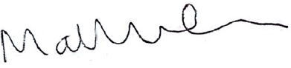

Matthew Cole (Chairing Member)

The Scottish Fuel Poverty Advisory Panel
7th Floor
Atlantic Quay
150 Broomielaw
Glasgow
G2 8LU

